PRESS RELEASE

CIFA @ WOC 2017 LAS VEGAS- C5372

Truck mounted pumps

For the range of truck-mounted pumps, CIFA continues with implementation of the product strategy that emphasizes diversification of the range based on three lines: CARBOTECH, STEELTECH and CLASSIC. Three different configurations to best meet the various needs of each area and each company.

The top of the line is available with the “CARBOTECH” series that includes a range of models with complete configuration even in the standard version, 360° electronics management with control over the pumping unit, stabilisation and operating parameters, distribution arms in carbon fibre to guarantee sturdiness, light weight and less oscillation during the work phases.
The “STEELTECH” series offers the possibility of outfitting a wide range of accessories and optional equipment on the configurable product. With particular attention to the total weight to comply even in the European road limits, this is the range with the most models and configuration variations. An extended warranty is available for the “STEELTECH” range.
The “CLASSIC” range includes a reliable, easy-to-service, very standardised product in a standard colour and configuration with no optional equipment or accessories available. The warranty provided is 12 months from delivery. This range is available in a limited number of models in a few selected markets which do not require any diversification of the product configuration.

The following will be on display in the stand:
CARBOTECH range: K60H
STEELTECH range: K42L

CARBOTECH RANGE

K60H
Thanks to its lightness derived from the new design and the carbon fiber technology used for the boom the K60H is very light for a machine of its class and can be fitted on 4 and 5 axle vehicle chassis.
The weight limit is always widely observed in order to allow the users to load accessories, water, diesel and anything else without violating traffic laws and/or any special permits and/or the technical limits of the vehicles.
Assembly on 5 axles allows excellent load distribution on the individual axles in order to permit travelling even in those countries where these types of laws are the most restrictive, such as the US.

The K60H has a 60-metre arm made up of 6 sections (the last three in carbon fibre) with RRZ folding geometry.

The K60H mount the new and high performance HP1808ECX closed circuit pumping unit with a maximum capacity of 180m3/h, 83 bar maximum pressure and 260mm concrete tubes that allow the maximum cycle per minute to be held to 27. In fact, a low number of cycles reduces wear and therefore the costs connected with operating the machinery.

The standard outfitting for these models, as for the entire CARBOTECH range, is particularly complete with accessories: besides the advanced machinery managements system SMARTRONIC GOLD display with automatic stability control and diagnostics, it stands out for its double thickness CIFA Long Life Pipes, as well as stabilisation conceived and designed based on the length of the arm.

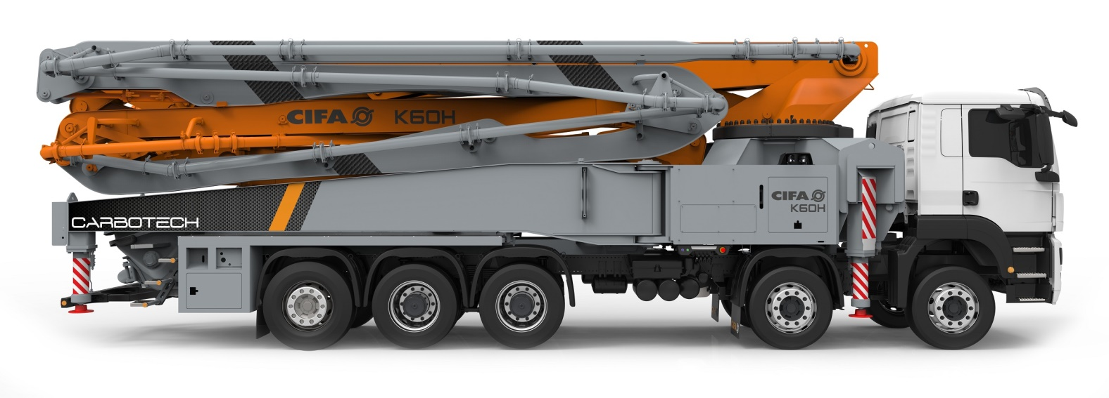
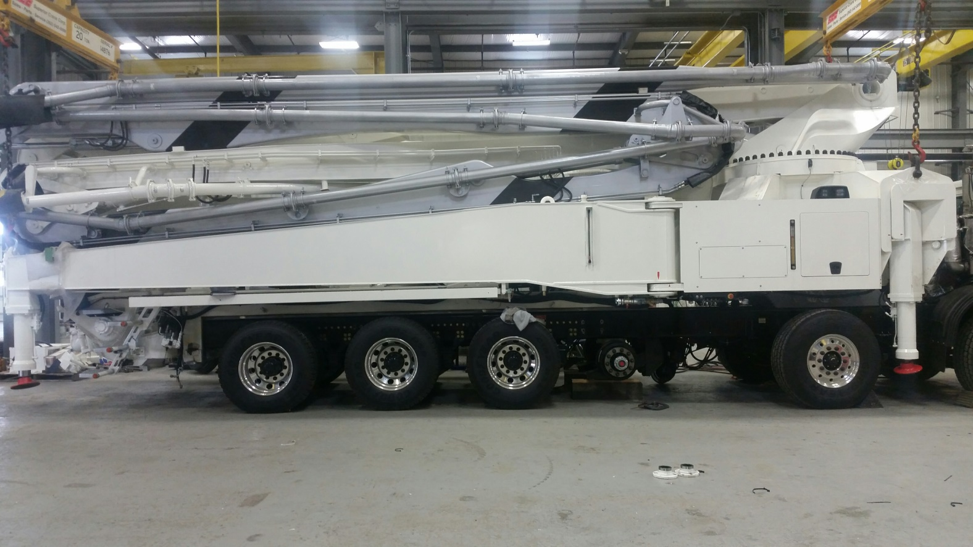

STEELTECH RANGE

K42L
In the Las Vegas show CIFA introduces for the American market the K42L, launched in Europe in 2016, this machine is widely appreciated for its versatility, with its newly designed 5-sections-boom and a length of 42 meters, an optimal weight distribution on many chassis.

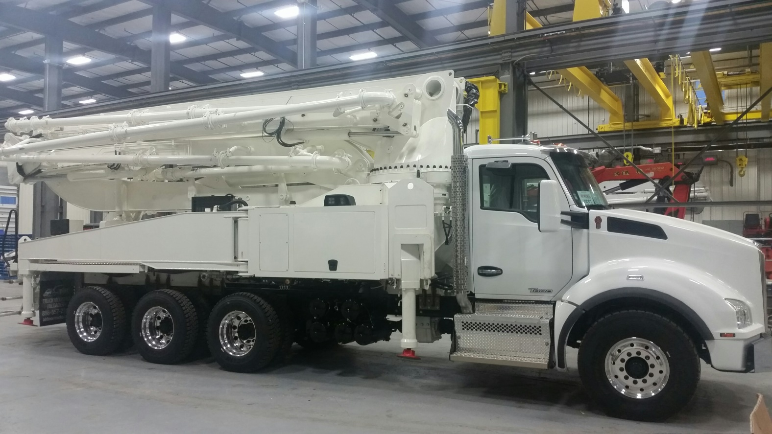

Information on CIFA
CIFA is a full-liner manufacturer of machinery and equipment for concrete work, leader in the Italian market and one of the major players on a global level. Part of the Chinese industrial group Zoomlion since 2008, CIFA is a highly international company with sales and support networks on every continent and able to offer customers, not only a range of reliable and quality products, but also financial support through Zoomlion Capital Financial Services. For more information see our website at www.cifa.com

December 2016

CIFA SpA
Adalberto Marcello
Tel: +39 02 99013221
Mob.: +39 346 0542890
communication@cifa.com
adalberto.marcello@cifa.com

